SmartBranch360
Network Design Document
Secure Branch Office Network — Design, Security & Troubleshooting Reference

Submitted by: Deepesh Nayak
College: Medi-caps University, Indore
Course: B.Tech CSE (AI Specialization), Batch 2023–2027
AICTE Internship Student Registration ID : STU69d54005c39db1775583237
Technology: Networking
Submission Date: 30 August 2026

This project was completed individually by the above-mentioned student.

1. Project Overview
SmartBranch360 is a secure branch-office network that includes wired employees, guest Wi-Fi, an internal server, internet access, and secure device management. The network was designed and built in Cisco Packet Tracer using VLAN segmentation, routing, DHCP, NAT, and ACLs.
This document covers: the topology diagram, VLAN/IP address plan, security rules, normal-operation test results, and 5 fault-injection scenarios along with their fixes.

2. Network Topology
The diagram below shows the complete SmartBranch360 topology — BranchRouter (2911) connects to the internet cloud, Switch1 is the distribution layer connecting Switch2 (access), AP-Guest, Server1, and Mgmt-PC, and Switch2 connects the 8 employee PCs. 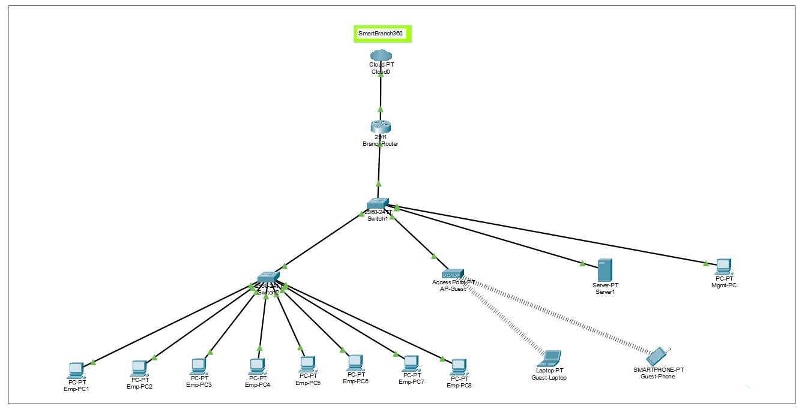

Figure: SmartBranch360 complete network topology — showing Cloud0 (ISP), BranchRouter, Switch1 & Switch2, AP-Guest with guest devices, Server1, Mgmt-PC, and all Employee PCs (Emp-PC1–Emp-PC8).

2.1 Device Roles
Device | Role
Cloud0 (Cloud-PT) | Simulated ISP / internet connection
BranchRouter (2911) | Edge router — routing between VLANs, DHCP, NAT, ACLs
Switch1 (2960-24TT) | Distribution switch — trunks to router, Switch2, AP, Server, Mgmt-PC
Switch2 (2960-24TT) | Access switch — connects 8 employee PCs on VLAN 10
AP-Guest | Wireless access point for Guest VLAN 20 (SSID: SmartBranch-Guest, WPA2-PSK)
Server1 | Internal server, static IP on VLAN 30
Mgmt-PC | Management workstation, only device allowed to SSH into devices
Emp-PC1 – Emp-PC8 | Employee wired endpoints, VLAN 10, DHCP assigned
Guest-Laptop / Guest-Phone | Wireless guest endpoints, VLAN 20, DHCP assigned

3. VLAN and IP Address Plan
VLAN ID | Name | Subnet | Gateway
10 | Employee | 192.168.10.0/24 | 192.168.10.1
20 | Guest | 192.168.20.0/24 | 192.168.20.1
30 | Server | 192.168.30.0/24 | 192.168.30.1
99 | Management | 192.168.99.0/24 | 192.168.99.1

3.1 Static Assignments
Device | IP Address | Subnet Mask | Default Gateway
Server1 | 192.168.30.10 | 255.255.255.0 | 192.168.30.1
Mgmt-PC | 192.168.99.10 | 255.255.255.0 | 192.168.99.1

3.2 DHCP Pools
Pool Name | Network | Default Router | DNS Server
EMPLOYEE_POOL | 192.168.10.0/24 | 192.168.10.1 | 8.8.8.8
GUEST_POOL | 192.168.20.0/24 | 192.168.20.1 | 8.8.8.8

4. Security Rules

4.1 ACL 120 — Guest Isolation
The Guest VLAN (20) must not have access to the Server VLAN (30) — guests should only be able to use the internet, not reach the internal server. This ACL is bound inbound on the router's Gi0/1.20 sub-interface.
Seq | Action | Source | Destination
10 | deny | 192.168.20.0/24 | 192.168.30.0/24
20 | permit | any | any

4.2 ACL 10 — Secure Management (SSH restriction)
SSH access to network devices is allowed only from the Management VLAN (99) — SSH is blocked from any employee or guest device. This is applied on the VTY lines.
Seq | Action | Source
10 | permit | 192.168.99.0/24
20 | deny | any

4.3 NAT Overload — Internet Access
Employee and Guest VLANs get internet access through NAT overload (PAT) via the router's WAN interface (Gi0/0).
ip nat inside source list 1 interface GigabitEthernet0/0 overload

5. Normal Operation — Test Results
Test | Result
Employee → Server (ping) | PASS — reachable
Employee → Internet (NAT translation verified) | PASS — translation entries confirmed via 'show ip nat translations'
Guest → Server (ping) | PASS (blocked as expected) — 'Destination host unreachable' due to ACL 120
SSH restriction test | PASS — Mgmt-PC could SSH in; Emp-PC1 was refused

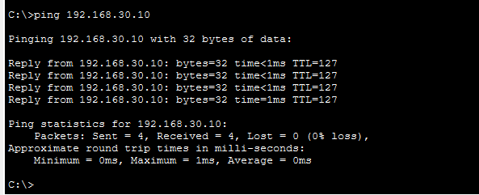
(1) successful ping from an Employee PC to the Server
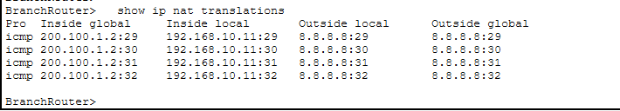
(2) show ip nat translations' output
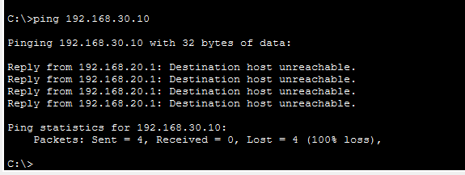
(3) failed ping from Guest to Server
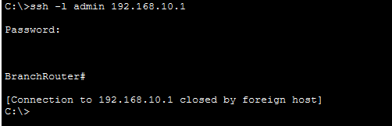

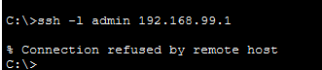
(4) successful SSH login from Mgmt-PC vs refused SSH from an Employee PC.

6. Fault Scenarios & Troubleshooting Notes
5 faults were deliberately injected, verified, and fixed. Each fault's root cause and fix is given below.
# | Fault Injected | Symptom | Root Cause | Fix Applied
1 | VLAN 20 removed from Switch1 trunk | Guest total isolation — no connectivity at all | VLAN 20 was accidentally removed from the trunk port's allowed-VLAN list | Re-added VLAN 20 to the trunk allowed list
2 | Wrong static gateway on Emp-PC2 | Server unreachable from Emp-PC2 only | An incorrect default gateway IP was manually set on the PC | Set the correct gateway (192.168.10.1)
3 | Extra ACL rule added on wrong interface | No visible effect — traffic continued normally | The ACL rule was created, but it wasn't bound to the interface where it needed to apply | Removed the extra/unbound rule
4 | NAT overload rule removed | Internet access fails — no NAT translation happening | The 'ip nat inside source list 1 ... overload' command was accidentally deleted | Reconfigured the NAT overload rule
5 | DHCP pool gateway changed | Server unreachable for DHCP clients (wrong gateway handed out) | The DHCP pool's default-router value was set incorrectly | Reverted the pool's default-router to the original gateway

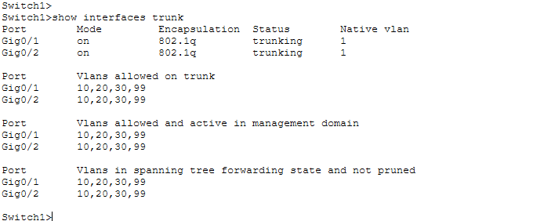
Fault #1 verification — Fixed. show interfaces trunk output confirms VLAN 20 is present on both Gig0/1 and Gig0/2 trunk ports, restoring Guest VLAN connectivity across the trunk.
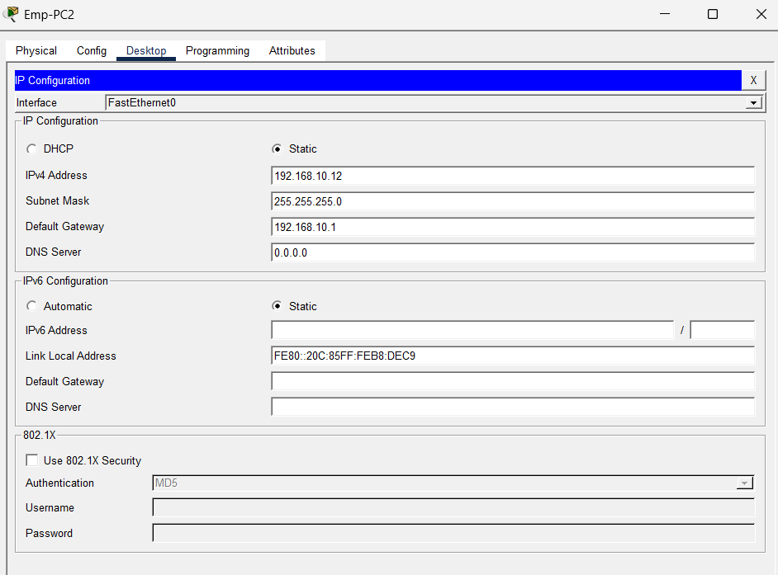
Fault #2 verification — Fixed. Emp-PC2's IP Configuration confirms the Default Gateway is correctly set to 192.168.10.1, restoring connectivity to Server1 and other VLANs.

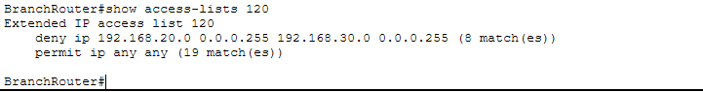
Fault #3 verification — Fixed. show access-lists 120 confirms only the intended 2 rules exist (deny Guest→Server, permit any any) — the earlier extra unbound rule has been removed.

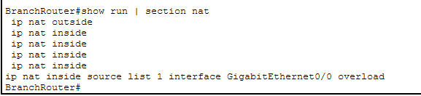
Fault #4 verification — Fixed. show run | section nat confirms the NAT overload rule is present, restoring internet access for Employee and Guest VLANs
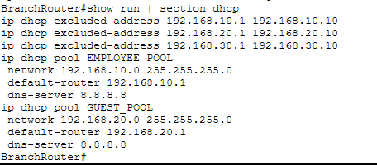
Fault #5 verification — Fixed. show run | section dhcp confirms both DHCP pools hand out the correct default-router (192.168.10.1 for Employee, 192.168.20.1 for Guest).

7. Python Assurance Tool (Reference)
A Python script (checker.py) was built to validate VLAN trunking, NAT, DHCP, ACLs (including interface binding), and static PC IPs against requirement.yaml (the source-of-truth design). Each finding is printed as PASS / WARN / FAIL along with a symptom and a suggested fix.
The full script, requirement.yaml, sample data, and sample validation report are submitted separately in the 'SmartBranch360_PythonChecker.docx' file (a separate deliverable).
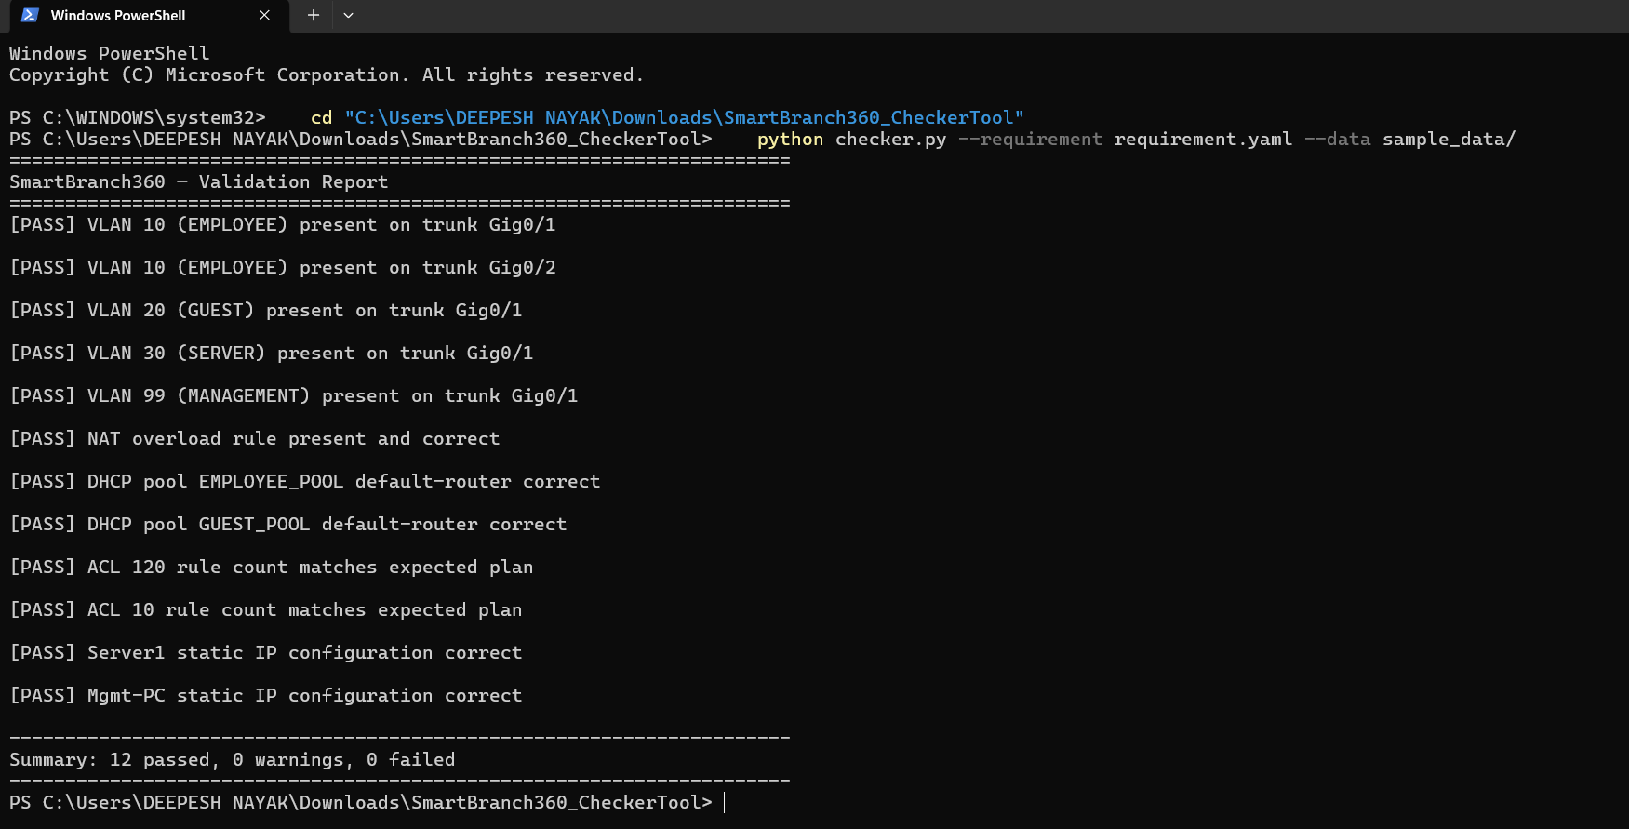
Figure: Python Checker Tool run showing SmartBranch360 validation report — all VLANs, NAT, DHCP, ACLs, and static IP checks passed successfully (12/12).

8. Conclusion
The SmartBranch360 network was successfully designed, built, and tested — with VLAN segmentation, secure inter-VLAN routing, guest isolation, restricted management access, and internet connectivity. Troubleshooting was practiced by injecting 5 fault scenarios, and a Python-based assurance tool was built to automatically detect future configuration drift.

